Inventory Management for a Retail Store

Spandhana Vanguru

<https://github.com/vspandhana/Database-Project.git>

November 2, 2022

**Identify the specific products that you sell related to the theme above, and write a short description of your business that includes what you sell, the size of your organization, general locations, and annual sales goals.**

In this project I am going to setup the database system for a retail store, this database will be able to use with both web application and desktop application but for this particular project, it will be connected with desktop application. The retail store sells the different kind of daily routine household goods, and it will have the variety of categories, for example, Crockery, edible things, cosmetics, drinks, dairy products, Washing products, etc.

It is a small store, and it is first of its branch, so we can say it is a small organization for now. As far as about the locations, since it is the first branch so it has only one location. And good margin of the profit from sale is 5% to 20%, and will try to achieve the goal through this.

**Compare your business to a real one by researching the annual sales and number of employees that the real business has.**

If we see on a bigger level then we can say Walmart is the similar business.

2021 sales: 459.51 billion (<https://nrf.com/resources/top-retailers/top-100-retailers/top-100-retailers-2022-list>)

Number of employees: 2.3 million worldwide (<https://corporate.walmart.com/askwalmart/how-many-people-work-at-walmart>)

**Now that you have an idea of how big your business is, you can start designing the network architecture that will eventually store your database. Use the information in the Week 1: Architectures power point to specify your n-tier Client Server setup. Think about the number of tiers your network needs, and what purpose each tier servers. If you have a very large system, maybe you need to distribute your database. Your setup should represent your business size and global reach.**

In this project, I am using 3-tier architecture, it also depends on the nature of the business, like how vast it is or how low scale it is, so depending on the scalability we choose that how many tiers we need. Here in below figure, we can see that there are 3 tiers, first tier is client tier, we can also say that it is user interface from where user will request for the data it needs, then this request is received by the application tier which is second tier, and it acts as the bridge between database tier and the client tier, and then database tier receives the request and do processing on it and send the relevant data to application tier and then that application tier send it to client tier.

* Tier 1
  + Task: User interface
* Tier 2
  + Task: Business Logic and Data processing logic
* Tier 3
  + Task: Data validation and Database access

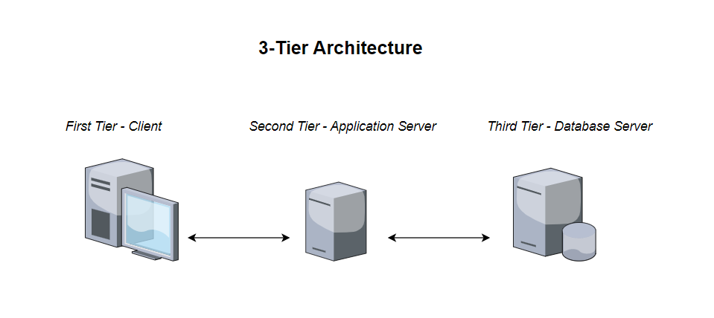

*Fig: Three Tier Network Architecture Diagram*

**The business will need to store many different types of data. That means elements of your business related to building and selling your products, not computer data types. Think about 5 important types of data that are related to your business. What do you need to track? List those types in your report.**

For this project following data types will be required;

* Varchar
  + To store the name of the product, category, description, name of the users, etc.
* Integer
  + To store the Product number, Phone number of user/employee, quantity of the product etc.
* Password
  + To store the password of the user
* Date Time
  + To store the manufacturing and expiry date of the product, product sold on which date, product added on which date etc.

**Assume that your business is more than 10 years old and needs to communicate with your new Cloud database setup. The file formats you use to represent business data are incompatible with the Cloud software requirements. Knowing that you need a solution to transfer your data to the new system.**

Middleware is the tool that we studied in the lecture that is used for the data translation.

Five current examples of this tool are as follows: (<https://azure.microsoft.com/en-us/resources/cloud-computing-dictionary/what-is-middleware/#:~:text=Common%20middleware%20examples%20include%20database,%2C%20and%20transaction%2Dprocessing%20monitors>)

1. Database Middleware
2. Application Server Middleware
3. Message Oriented Middleware
4. Web Middleware
5. Transaction Processing Middleware

Three common data formats are as follows:

1. JSON
2. XML
3. CSV